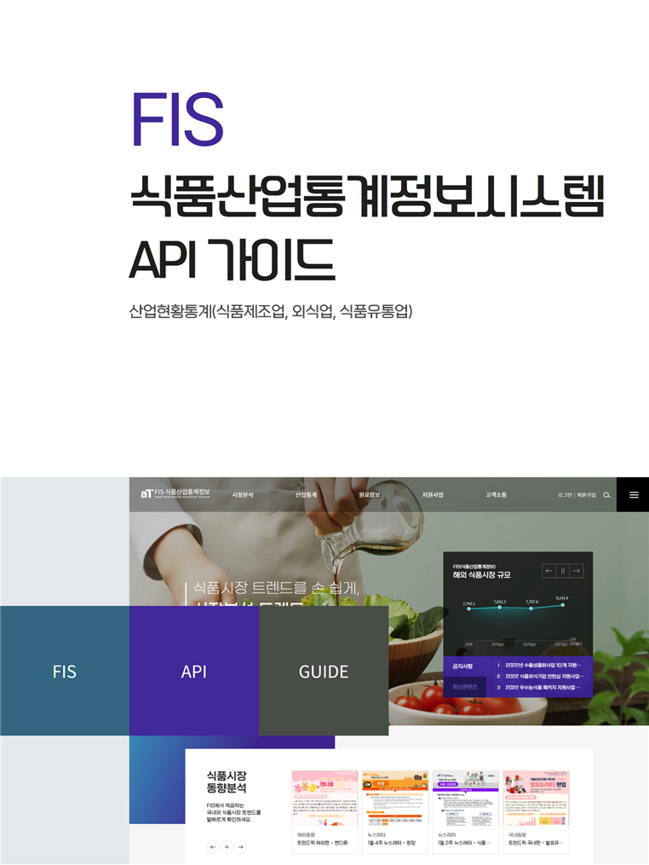

1. **요청URL**

https://www.atfis.or.kr/home/api/food/stats/industry.do

|  |  |  |  |
| --- | --- | --- | --- |
| **요청변수** | **값** | **설명** | **필수여부** |
| **apiKey** | string | 인증키 | Y |
| **beginYear** | string | 시작연도(YYYY) | Y |
| **endDate** | string | 종료연도(YYYY) | Y |
| **category1** | string | 분류코드 | Y |

1. **샘플URL**

https://www.atfis.or.kr/home/api/food/stats/industry.do?apiKey=z9JeRfaB44up466XHs+5pTcV31n58LqRkSHZ8H66xbw=&beginYear=2018&endYear=2020&category1=PRODUCE

1. **출력결과필드**

|  |  |  |
| --- | --- | --- |
| **필드** | **값** | **설명** |
| **fdmseSectorCd** | string | 분류코드명 |
| **fdmseNumber** | double | 숫자 값(금액 또는 수) |
| **fdmseUnit** | string | 단위 |

1. **샘플JSON**

{

"2020":[ {"fdmsSectorCd":"사업체수","fdmsNumber":61620.0,"fdmsUnit":"개"} ]

}

1. **분류코드(category1)**

|  |  |
| --- | --- |
| **코드** | **코드명** |
| **PRODUCE** | 식품제조업 산업현황 |
| **EATOUT** | 외식업 산업현황 |
| **DISTIBUTION** | 식품유통업 산업현황 |